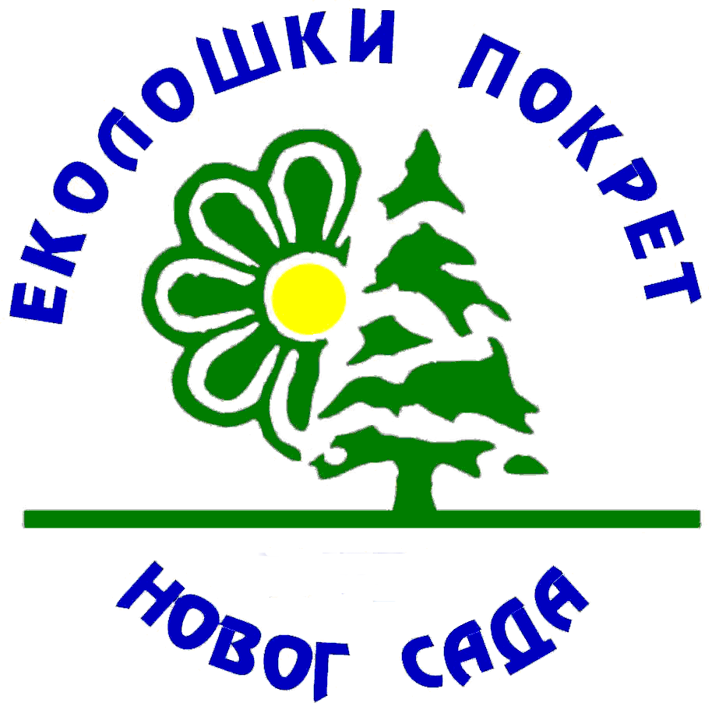

26th INTERNATIONAL ECO-CONFERENCE®
12th ECO-CONFERENCE on SAFE FOOD

NOVI SAD, SERBIA, 21 - 23 September 2022

I N V I T A T I O N

Organizer:

ENVIRONMENTAL MOVEMENT OF NOVI SAD
Bul. Cara Lazara 83/1, 21102, Novi Sad, SERBIA
E-mail: ekopokretns@gmail.com
Website: www.ekopokret.org.rs

Patronage:

MATICA SRPSKA

Co-organizers
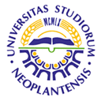 |  |  |  |  | 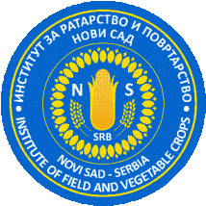
UNIVERSITY OF  NOVI SAD | RUSSIAN STATE AGRARIAN UNIVERSITY - MTAA |  | INTERNATIONAL INDEPENDENT ECOLOGICAL POLITICAL UNIVERSITY IN MOSCOW |  | INSTITUTE OF FIELD  AND VEGETABLE  CROPS - NOVI SAD
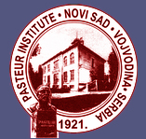 |  |  |  | 
PASTEUR INSTITUTE OF NOVI SAD, SERBIA |  | SCIENTIFIC INSTITUTE FOR VETERINARY MEDICINE ,,NOVI SAD" IN NOVI SAD, SERBIA |  | LEGAMBIENTE  d'ITALIA

Honorary Commitee

President:
- Dragan Stanic, Ph.D, President, Matica srpska, Serbia

Vice-Presidents:

- Dejan Madic, Ph.D, Rector, University of Novi Sad, Serbia
- V.I. Trukhachev, Ph.D, Rector, Russian University of Agriculture, Moscow, Russian Federation
- Stanislav A. Stepanov, Ph.D, Rector, International Independent Ecological-Politicology University, Moscow, Russian Federation
- Jegor Miladinovic, Ph.D, Head, Institute of Field and Vegetable Crops, Novi Sad, Serbia
- Nenad Vranjes, Ph.D, Head, Pasteur Institute, Novi Sad, Serbia
- Sava Lazic, Ph.D, Head, Scientific Veterinary Institute Novi Sad, Novi Sad, Serbia
- Vittorio Cogliati Dezza, Ph.D, President, Legambiente, Rome, Italy
- Natasa Saric, Acting Head, Institute for Nature Conservation of Serbia, Department of Geodiversity, Novi Sad, Serbia

Scientific Committee

President:

- Miroslav Malesevic, Ph.D, Faculty of Agriculture, University of Novi Sad, Serbia

Vice Presidents:

- I.I. Vasenev, Ph.D, Vice Rector, Russian State Agrarian University, MTAA, Moscow, Russian Federation
- Marfenin N. N., Ph.D, Vice Chancellor, International Independent Ecological-Politicology, University in Moscow, Russian Federation
- Moreno Baccichet, Ph.D, Faculty of Philology and Philosophy, University of Ferrara, Italy
- Nikola Jorgovanovic, Ph.D, Vice Rector of Science and Art, University of Novi Sad, Serbia
- Ana Jeromela Marjanovic, Ph.D, Assistant Head of the Science and Research, Institute of Field and Vegetable Corps, Novi Sad, Serbia
- Dusan Lalosevic, Ph.D, Head, Pasteur Institute of Novi Sad, Serbia
- Tamas Petrovic, Ph.D, Assistant Head of Science, Scientific Veterinary Institute, Novi Sad, Serbia
Secretary:

- Ljubica Aleksic, Assistant Director, Environmental Movement of Novi Sad, Serbia

Members

- Academician Serbislav Dencic, Institute of Field and Vegetable Crops, Novi Sad, Serbiac
- Academician Branka Lazic, The Faculty of Agriculture, University of Novi Sad, Serbia
- Academician Vukadin Leovac, Faculty of Science, Department of Chemistry, University of Novi Sad, Serbia
- Radmila Bojovic, Ph.D, Faculty of Agriculture, University of Belgrade, Zemun, Serbia
- Desanka Bozidarevic, Ph.D, Resident Professor, Faculty of Agriculture, University of Novi Sad, Serbia
- Ales Golja, Ph.D, Faculty of Civil and Geodetic Engineering, University of Ljubljana, Slovenia
- Jasna Grabic, Ph.D, Faculty of Agriculture, University of Novi Sad, Serbia
- Ivana Djujic, Ph.D, Resident Professor, Faculty of Biology University of Belgrade, Serbia
- Jela Ikanovic, Ph.D, Faculty of Agriculture, University of Belgrade, Serbia
- Gabrijela Jovcev, Ph. D, Institute of Biodiversity and Ecosystem Research, Sofia, Bulgaria
- Vladan Joldzic, Ph.D, Resident Professor, Faculty of Biology and Chemistry, University of Belgrade, Serbia, Institute for Criminological and Sociological Research, Belgrade, Serbia
- Ana Jovicic Vukovic, Ph.D, High Business School, Novi Sad, Serbia
- Ksenija Mackic, Ph.D, Faculty of Agriculture, University of Novi Sad, Serbia
- Ivana Maksimovic, Ph. D, Resident Professor, Faculty of Agriculture, University of Novi Sad, Serbia
- Zeljko Mihaljev, Ph.D, Higher Research Associate, Science Veterinary Institute Novi
Sad, Serbia
- Aleksandar Milovanovic, Ph.D, Higher Research Associate, Science Veterinary Institute, Novi Sad, Serbia
- Andreja Milovanovic, School of Law, University of Montenegro, Montenegro
- Rodoljub Oljaca, Ph.D, Resident Professor, Faculty of Forestry, University of Banja Luka, Bosnia and Herzegovina
- Vera Popovic, Ph.D, Science Counselor, Institute of Field and Vegetable Corps, Novi Sad, Serbia
- Marina Putnik Delic, M.Sc, Faculty of Agriculture, University of Novi Sad, Serbia

- Aleh Rodzkin, Ph.D, International Sakharov Environmental University, Minsk, Belarus
- Atila Salvai, Ph.D, Faculty of Agriculture, University of Novi Sad, Serbia
- Ivan Simunic, Ph.D, Resident Professor, Faculty of Agriculture, University of Zagreb, Croatia
- Radmila Sovljanski, Ph.D, Resident Professor, Faculty of Agriculture, University of Novi Sad, Serbia
- Velibor Spalevic, Ph.D, Biotechnical Faculty, University of Montenegro, Montenegro
- Mohammad Taghi Razavian, Ph.D, Associate Professor, Department of Geography, Sahid Beheshti University, Evin, Tehran
- Ion C. Ungureanu, Ph.D, Professor, Faculty of Agricultural Sciences and Veterinary Medicine, University of Bucharest, Romania
- Lu Zhongmei, Ph.D, University of Beijing, University of Wuhan, Vice President of the High People’s Court, Hubei, Wuhan, China, Member of the National People’s Congress of the Republic of China

Organizational Committee

President:
- Nikola Aleksic, President, Environmental Movement of Novi Sad, Serbia

Vice President:
- Angelo Mancone, Legambiente, Verona, Veneto, Italy

Secretary:
- Zoran Kovacevic, Organizar, Environmental Movement of Novi Sad, Serbia

Members:
- Jela Ikanovic, Ph.D, , Serbia, Faculty of Agriculture, University of Belgrade, Serbia
- Zeljko Mihaljev, Ph.D, Higher Research Associate, Science Veterinary Institute Novi Sad, Serbia
- Djordje Okanovic, Ph.D, Research Associate, Institute of Field and Vegetable Corps, Novi Sad, Serbia
- Dragana Popovic, Faculty of Economy, University of Novi Sad, Serbia
- Vera Popovic, Ph.D, Science Counselor, Institute of Field and Vegetable Corps, Novi Sad, Serbia
- Vera Rajicic, Ph.D, Faculty of Agriculture, University of Nis, Serbia
- Dragoslav Stoiljkovic, Ph.D, Faculty of Technology, University of Novi Sad, Serbia
- Milan Vurdelja, Mr.Sc, Rectorate,University of Novi Sad, Serbia
- Bratimir Nesic, Graduate Engineer, Assistant President, Environmental Movement of Novi Sad, Serbia
- Luka Vujasinovic, Web Administrator, Environmental Movement of Novi Sad, Serbia

GENERAL OBJECTIVES

The significance of safe food production and consumption has been widely recognized, as the risks of food nutritive value reduction increase due to its industrial production. Even in developed countries industrial food production brings about new threats to human health.
Various issues concerning safe food are being increasingly addressed both in professional and general publics of the developed countries, while the post-socialist ones are rather lagging behind them.
With the general aim to contribute to communicating valid knowledge and supporting exchange of opinions and experiences as well as making the knowledge actionable, the Ecological Conference® on Safe Food has been held in even years since the year 2000. The conference aims to:
- address, at a scientific-expert level, a wide range of key issues concerning safe food production and environmental consciousness;
- discuss and assess the causes of environmental imbalance in conventional agricultural production and the impact of various pollution sources on agricultural production at present;
- offer practical solutions, based on scientific indicators and expert opinions, to help meet present challenges and those that lie ahead;
- present relevant proposals and suggestions for the long-term strategic programs in food production (in the industrialized, controlled, integral, alternative and sustainable agriculture) without negative effects on human health and the environment.

SUBJECT AREAS

The Eco-Conference® is open to all the issues concerning safe food, from the point of its production, to the point of consumption.
Contributions that are most welcome are those that point out good or bad practices, while validating factors affecting food safety and quality in the following subject areas:

- Environmental factors and food production
- Correct choice of seed (genetic) material
- Status and preparation of soil as the basic substrate for the production of food and feed
- Use of fertilizers and pesticides in integrated plant protection
- Food processing technology
- Economic aspects, marketing and packaging of safe food

SESSION TOPICS

The Conference will work in sessions. The final list of sessions – timing of the Conference will depend on the number of papers submitted.

The following session topics have been proposed by the Scientific Committee:

- Climate and production of safe food.
- Soil and water as the basis of agricultural production.
- Genetics, genetic resources, breeding and genetic engineering in the
safe food production.
- Fertilizers and fertilization practice in the production of safe food.
- Integrated protection of plants, the use of pesticides and the effects of residues.
- Agricultural production in view of sustainable development
- Production of field and vegetable crops.
- Production of fruits and grapes.
- Livestock husbandry from the aspect of safe food production.
- Processing of agricultural products in the framework of safe food production.
- Economic aspects and marketing as segments of the production of safe food.
- Food storage, transportation and packaging.
- Nutritional food value and quality nutrition.
- Legal aspects of protecting brand names of safe food.
- Environmental models and software in production of safe food.

NOTE:

Topics listed above should be regarded as the subject framework. Participants are kindly requested to submit only original scientific or technical papers that have not been published before and in which the practical possibilities are stressed for application of certain solutions in production of safe food.
All papers will be reviewed. Papers accepted by the Scientific Committee will be published in the Conference proceedings. Each participant may be the principal author of one paper alone.

OFFICIAL LANGUAGES OF THE 2022 ECO-CONFERENCE®

The Eco-Conference® official languages are Serbian and English.
Thematic collection of papers will be published in English.

PARTICIPATION FEE

Participation fee per paper is 50 €. Payable by the first author.
Participation fee after June 1st per paper is 60 €.
Participants (attendants) pay the participation fee in the same amount.
The participation fee implies that the following is provided for the authors of papers and participants (attendants):
- Eco-Conference® 2022 proceedings with papers printed in whole, in English
- daily meals (lunches) in an exclusive restaurant,
- refreshments during the working part of the Eco-Conference® 2022 and
Participation in a variety of accompanying cultural events:
- Nature preservation exhibition
- Concert
- Official banquet
- Field excursion (lunch included)

Participation fee is to be paid to the foreign currency account of the Ecological movement of Novi Sad.

Please find listed below the instructions for your incoming EUR payments, as follows:

Participation fee is payable to the foreign currency account of the Ecological Movement of Novi Sad: Beneficiary: Eko-konferencija Novi Sad 1995, Bul. Cara Lazara 83/1, 21102
Novi Sad, Serbia.
Please find listed below the instructions for your incoming EUR payments, as follows:

MONEY TRANSFER PAYMENT INSTRUCTIONS IN EUR

In order to remit EUR amounts to your account with VOJVOĐANSKA BANKA AD please proceed according to
following payment instructions:
Kind regards

"VOJVOĐANSKA BANKA AD
MEMBER OF OTP GROUP"
14.03.2018

56A Intermediary Institution - BIC
DEUTDEFF
DEUTSCHE BANK AG
FRANKFURT AM MAIN, DE, GERMANY
57A Account With Institution - BIC
/100 9365289 0000
VBUBRS22
OTP BANKA AD
NOVI SAD, RS
59 Beneficiary Customer - Name & Address
/RS35355000320063729015
ECO-CONFERENCE OF NOVI SAD 1995
BULEVAR CARA LAZARA 83/1-11
NOVI SAD, RS

Authors from Serbia pay the participation fee in dinar counter-value onto the special purpose account at Vojvođanska banka a.d. Novi Sad under the name of:

Eko-konferencija Novi Sad 1995
Number: 325-9500600041488-37

DEADLINES

Please send us your application form as soon as possible.
July 1st 2022 - deadline for submission of papers
August 31st, 2022 - deadline for payment of participation fee

Papers for which the participation fee is not paid within the above-mentioned deadline shall not be published in the Proceedings of the Eco-Conference® 2022.

VENUE OF THE OFFICIAL OPENING OF THE ECO-CONFERENCE®

Public Company Sports and Business Center "Vojvodina", Sutjeska Street no. 2, Novi Sad

VENUE OF THE WORKING PART OF THE
ECO-CONFERENCE® 2022

Institute for Nature Protection of Vojvodina region, Radnicka Street 20A, Novi Sad,

EDITORIAL GUIDELINES

Papers should be submitted in correct English (whole), with the maximum 8 pages in A-4 with margins set to TOP: 62 mm; BOTTOM: 50 mm; LEFT: 45 mm; RIGHT: 40 mm, together with abstract and key words.
Papers written in poor English shall not be taken into consideration.
All papers are subject to reviews.

IMPORTANT NOTES:

Papers should be sent to the organiser's E-mail address, with confirmed receipt.
Use Microsoft Word for Windows to edit your papers
Use Times New Roman font, Single space and do not use Footnotes.
It is necessary to unify all headlines, quotation marks, dashes, listing marks etc.


Top 62 mm
Left 45 mm
Right 40 mm
25 mm
Bottom 50 mm
Space for official use (only on first page)

(One empty line, 10pt)
First author¹, Second author², ... (With titles - 10pt, bold, center)
¹First author’s institution/company (10pt, center)
²Second author’s institution/company (10pt, center)

(Three empty lines, 10pt)
TITLE OF THE PAPER IN ENGLISH NOT LONGER
THAN TWO LINES... (12pt, bold, all caps, center)
(Two empty lines, 12pt)

Abstract (10pt, bold, center)
(One empty line, 10pt)
Text of the abstract not longer then eight lines .... (9pt, first line indented - tab stop position - 0.5 cm, justify)
(One empty line, 10pt)
Key words: example, example, ... (10pt, italic, up to 5 key words)
(Three empty lines, 10pt)
INTRODUCTION
(12pt, all caps, center,)
(Two empty lines, 10pt)
The manuscript (10pt, first line indented - tab stop position - 0.5 cm, justify)
(Two empty lines, 10pt)

(Two empty lines, 10pt)
Figure 1. Title of the figure.
(10pt, italic, center)
(One empty line, 10pt)

Top 62 mm
Bottom 50 mm
Right 40 mm
Left 45 mm

(one empty line, 10pt)
Table 1. Title of the table. (10pt, italic, center)

(One empty line, 10pt)

Formulas are written as follows:
(One empty line, 10pt)
(1)
(One empty line, 10pt)
(Functions, variables and Greek letters, in italics, numerals and other symbols in plain lettering basic, font size is 10pt, indexes 7pt, symbols 14pt. If equations are numbered, numerals should be in line with the right margin, otherwise they are centered.)

(Two empty lines, 10pt)
CONCLUSION
(and all other headlines 12pt, all caps, center, without numeration)
(Two empty lines, 10pt)

(Two empty lines, 10pt)

REFERENCES (10pt, all caps, Alignment Left,)
(One empty line, 10pt)
- Petrović P., Petrović P.: Name of publication (title - italic), publisher, page, place, year. (10pt, numbered); list according to alphabetical order

NOTES:

- Papers shall not be text proved additionally. Authors shall be held responsible for correctness of the English language used.
- Papers written in poor English shall not be taken into consideration.
- Only papers that have not been published until now should be applied with.
- All papers are subject to reviews. After the review is completed the accepted papers shall be printed in the Proceedings of the Eco-Conference® 2022.
- The Scientific Committee keeps the right to decide on the method of presentation (poster or report) depending on author's wishes, the number of submitted papers and the planned agenda.
- The participants are entitled to act only once as leading authors and once as co-authors.

In the end, with our kind regards and gratitude for your readiness to contribute to successful organisation and holding of the 26th International Eco-Conference® 2022 we express our hope that your papers shall be submitted within the set deadlines.

POSTER DIMENSIONS

Dimensions for poster are 80 х 100 cm.

26th INTERNATIONAL ECO-CONFERENCE®
12th Internationational Eco-Conference® on SAFE FOOD
Novi Sad, Serbia, 21th – 23th September 2022

REGISTRATION FORM

Please return this form before deadline to :
EKOLOSKI POKRET NOVOG SADA, Vojvodjanskih brigada 17, 21000 Novi Sad, Serbia
E-mail : ekopokretns@gmail.com ; web site : www.ekopokret.org.rs

Title, first name and family name :
Institution or company :
Address :
Phone / Fax & Mobile Phone
E-mail :
Verbal presentation 
Paper title :
 |  |  |  |  |  |  |  |  | Session No. :
Category : |  |  |  | Review paper  Research paper 
Please send application as soon as possible
July 1st, 2022 - deadline for submission of papers
August 31st, 2022 - deadline for the payment of participation fee
Place and date : |  |  |  |  |  |  | Signature :

GENERAL AGENDA ECO-CONFERENCE® 2022

Wednesday, September 21th

Public Company Sports and Business Center "Vojvodina", Sutjeska Street no. 2

10.00-12.00 Official Opening of the Eco-conference® 2022
- Cultural-Entertainment Programme
- Opening of the Eco-conference® 2022
- Welcoming Addresses
- Opening Presentation by…
- Opening Presentation by…
- Cocktail

12.00-15.00 Lunch break

Working part

Institute for Nature Protection of Vojvodina Department - Working Unit in Novi Sad, Radnicka Street 20A

14.00-15.00 Poster displaying

15.00-19.00 Oral presentations
Poster session

17.00-17.30 Coffee break

20.00 Concert

Thursday, September 22th

08.00-09.00 Poster displaying

09.00-12.00 Oral presentations
Poster session

11.00-11.30 Coffee break

13.00-15.00 Lunch break

14.00-15.00 Poster displaying

15.00-19.00 Oral presentations
Poster session

17.00-17.30 Coffee break

20.30 Gala dinner marking the completion of the working part of the Eco-Conference

Authors shall have all appliances necessary for presentation of their papers (lasting up to ten minutes) at their disposal (video beam, graphoscope etc.)
The order of presentations shall be defined per sessions during the final work programme based on the submitted papers and possibilities for presentation.
Depending on the authors' wishes and the number of submitted papers, the Scientific Committee keeps the right to decide on the method of presentation (poster or complete paper) in compliance with the time frame planned for presentation of papers.
During the working part of the Eco-Conference® 2022 we shall organise a nature exhibition in the premises of the Institute for Nature Protection of Serbia - Working Unit in Novi Sad and participants can visit it during the planned breaks.

Friday, September 23^{tн}

Excursion:

10.00 Departure

15.00 Return to the hotels

HOTEL ACCOMMODATION IN NOVI SAD

Please, contact authorized travel agency for accommodation.

Authorized tourist agency:
KOMPAS  Bulevar Mihajla Pupina 15  21000 Novi Sad  Serbia | Phone: + 381 21 66 11 299  + 381 21 66 12 306  + 381 21 423 788  Fax: + 381 21 66 22 221  + 381 21 66 16 468  E-mail: kompasns@eunet.rs

